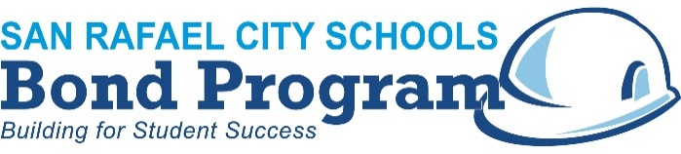

August 21, 2018

**Davidson Middle School Community Notice**

Construction on the new two-story classroom building at Davidson Middle School begins soon with completion scheduled for Summer 2019. In early September, the contractor will begin initial work installing new underground utility lines and performing other site work to prepare for construction. Some trees and plants will be removed to accommodate the site and location of the new building, but new trees and plants will be added to campus when construction is complete.

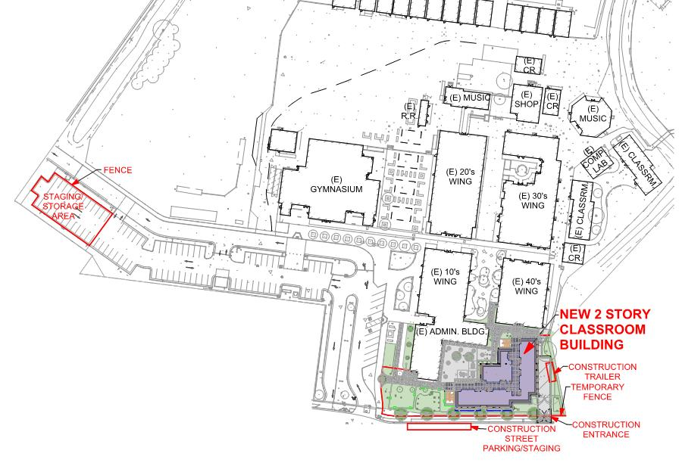

**September 2018:**

Begin underground work and grading for the new building and site

**Fall 2018:**

Begin new building construction

**Summer 2019:**

Complete construction

If you have any questions, please contact Dr. Dan Zaich, 415-492-3285 or [dzaich@srcs.org](mailto:dzaich@srcs.org).

**www.srcsbondprogram.org**